

[Company Address]

Zakeria Hassan

Business intelligence is critical in seeing opportunities and finding pitfalls in an organization. In this document we analyze the business processes of our client to design a business intelligence solution.

BI Business Requirements

# Table Of Content

Table of Content 2

Logical Model 3

Business Requirement 4

Data Requirements 5

# Logical Model

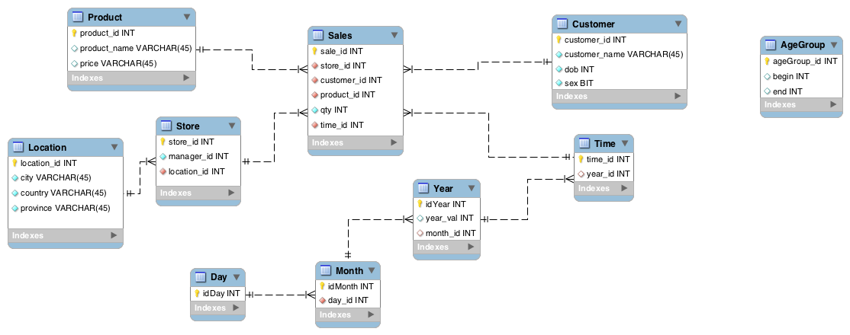

# Business Requirement Document

## Introduction:

Access to information is critical in this competitive economy because it gives better insight to how a company performs and assists in finding areas of improvement. Organizations receive large amounts of data and often may not find the information they are looking for. Enterprises need a way to quickly generate reports, analytics and data mining.

## Product Line:

* Personalized Golf Clubs
* Magnets
* Bedroom door signs
* Graduation plaques
* Retirement plaques
* Sports Jerseys
* License Plates
* Hockey Stick
* Basketball
* Baseball bat
* Coffee Mug
* Shoes
* Lighter
* Backpack
* Wallet

## Business Process:

Sales transactions can show key indications of how your business is performing. Understanding the business process is required to generate reports that will provide business value.

## Business Questions:

* How up to date would you like to data?
* Which cities in Ontario should we target to open retail stores.
* Which names will be the most important for each age group
* Sales volumes by store, product and product group
* Revenue by store, product and product group
* Profit by store, product and product group.
* How large can the database warehouse be ( < 4 TB is small) .
* How many cores, memory, processing power.
* How many users and what are they going to be doing?
* Size of the data and the usage complexity.
* Whether the warehouse needs to be active.
* Is it okay to take it offline to do a backup.
* Number of users using the application concurrent. Number of users simultaneous going into the system.
* Are you going to be up 24 by 7. Is HA required.
* Do you require Adhoc queries?
* If data is large and doesn't need to be all accessed at the same time could we do partitioning?
* Is there some data that doesn’t get accessed and can we archive data to reduce the size of the data store.